# Music 424 Assignment 1

## Mayank Sanganeria

1a) done

1b)

for 10ms attack and 200ms release

Attack:

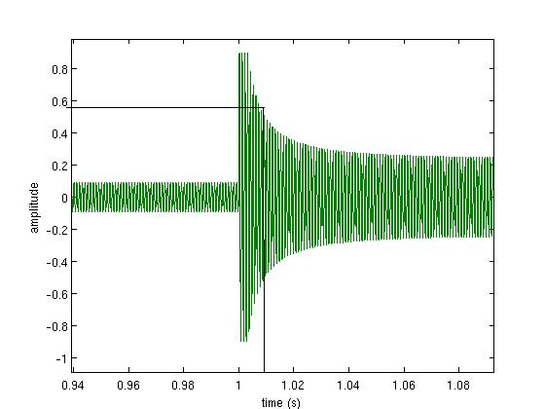

Release:

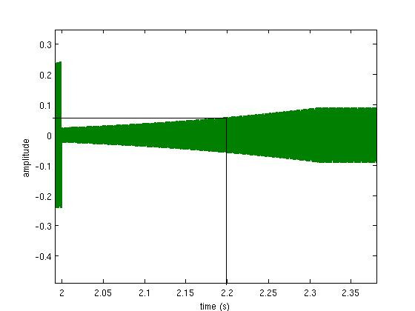

The attack and release times are marked in black

for 1ms attack and 50ms release

Attack:

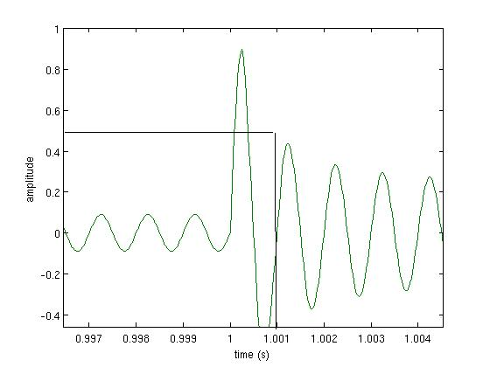

Release:

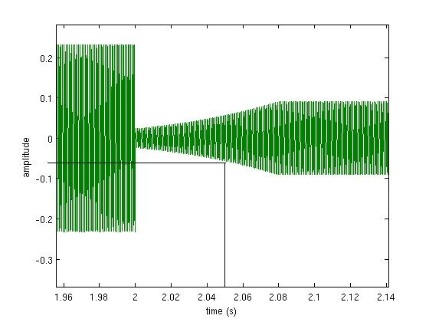

Rough Sketch of envelopes:

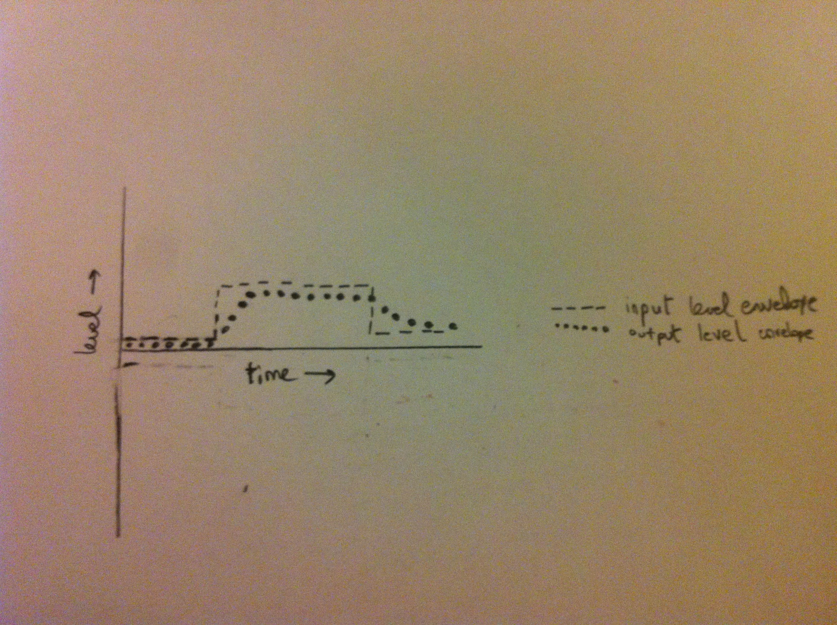

1c)

|  |  |
| --- | --- |
| Smooth | 0.1ms |
| Tinky | 1ms |
| Thuddy | 50ms |
| transparent | 100ms |

|  |  |
| --- | --- |
| Buzzy | 50ms |
| Roomy | 100ms |
| even | 200ms |

2.

The compressor output is much smoother than the limiter output

Compressor output:

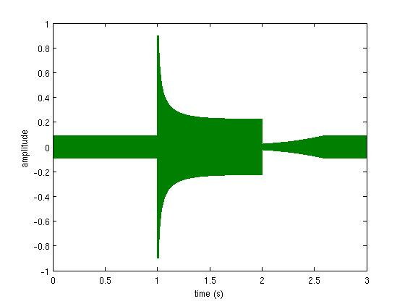

Limiter output:

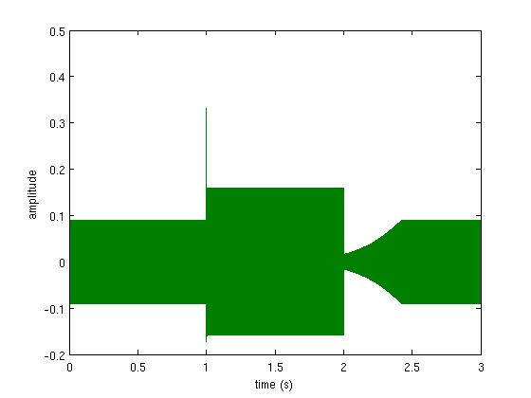

On drums and guitar, the Limiter is a lot more quite than the Compressor and appears much more subdued while the Compressor makes them sound brighter.

3.a)

p=2

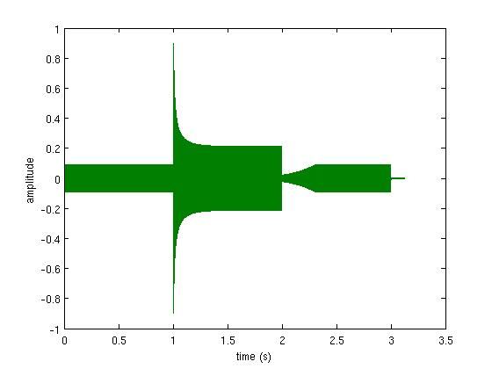

p=5

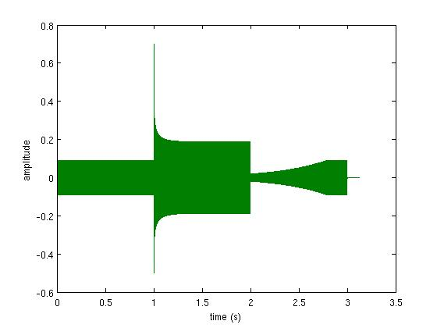

p=10

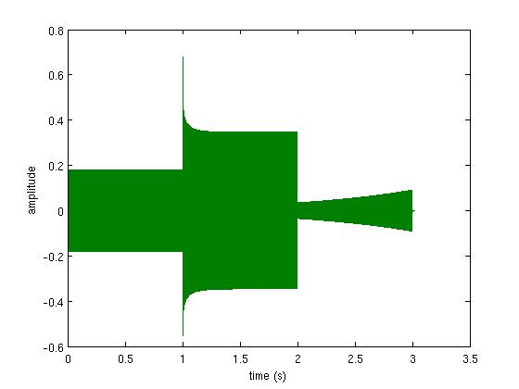

3.b) check next page